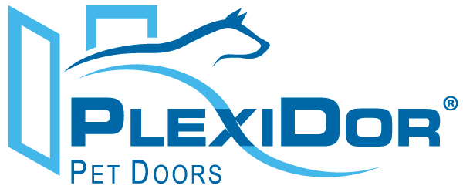

For Immediate Release
Maya Sullivan, PlexiDor Pet Doors
maya.sullivan@plexidors.net
941-752-7021 ext. 205

PlexiDor® Performance Pet Doors Releases Two New Innovative Dog Door Models

New Chew Proof Pet Doors for Dogs that Like to Chew

Sarasota, Fla. (November 1, 2012) – PlexiDor Pet Doors is proud to announce two new dog door designs to its already impressive lineup. Known for security and energy efficiency, PlexiDor now offers pet owners whose dogs have chewing problems a solution with the introduction of the PlexiDor Extra Large and the PlexiDor Top Swing series.
The newly released PlexiDor Extra Large door offers the same standard features of the already introduced line of pet doors with new features to accommodate dogs up to 220 pounds. The panels on the PlexiDor PD DOOR XL and PD WALL XL are manufactured using a solid 3/8 inch sheet of plexiglass and do not require costly replacement flaps. Additionally, panels also come equipped with factory installed chew-proof aluminum trim around all four edges.
The PlexiDor Top Swing is the perfect solution for dogs up to 100 pounds that like to chew. The PlexiDor PD TS Single Panel Top Swing features a single top swing plexiglass panel equipped with aluminum chew-proof trim. The entire line of door units and wall units includes a lock, key and steel security plate to keep out unwanted intruders.
PlexiDor Performance Pet Doors are available through a nationwide network of authorized dealers and online retailers with prices ranging from $149 to $1249. Visit www.plexidors.com for more information and to find a dealer near you.

About PlexiDor
Since 1985, PlexiDor Performance Pet Doors has manufactured pet doors at its facility in Bradenton, Fla. PlexiDor Performance Pet Doors are professionally engineered and manufactured from high-quality materials made in the United States in an effort to provide years of safe, trouble-free service for consumers and their pets. PlexiDor Pet Doors do not require costly vinyl replacement flaps and its frames are made from heavy-duty anodized aluminum that will not rust, bend, crack or warp. Engineered with energy efficient panels, PlexiDor Pet Doors will result in reduced energy costs, ideal for extreme climates. PlexiDor also offers a 5-year limited residential warranty and a
90-day money back guarantee.

###

