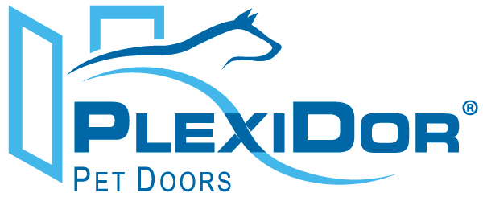
For Immediate Release
Maya Sullivan, PlexiDor Pet Doors
maya.sullivan@plexidors.net
941-752-7021 ext. 205

PlexiDor® Pet Doors Adds Security Feature

Bradenton, Fla. (June 17, 2013) – PlexiDor Performance Pet Doors has manufactured pet doors at its facility in Bradenton, Florida since 1985.
PlexiDor Pet Doors do not require costly vinyl replacement flaps. The unique saloon style, shatter resistant panels feature industrial grade weather seal and provide maximum energy efficiency. PlexiDor Pet Doors come with a lock, key and steel security plate.
Providing families with a safe and secure pet door for their home is PlexiDor’s highest priority. Now with the addition of the “Sliding Track with Flip Lock” accessory, PlexiDor has made it even easier to help prevent intruders from entering a home.
“The new Sliding Tracks with Flip Lock feature enables a homeowner to easily attach the steel security plate to their PlexiDor dog door”, says Robert Wollet, Sales Manager of PlexiDor. “Whether you leave your home for vacation or would like added security every day, the new sliding track accessory makes it even easier”.
PlexiDor sliding tracks attach to the left and right side of the interior frame of the PlexiDor dog door. Once attached, the user slides the steel security plate down the tracks into place. Simply secure the plate with the handy flip lock feature and you’re finished. The sliding tracks will not interfere with the lock and key.
The tracks are made of strong, lightweight aluminum and match the interior frame color of the door. Available colors are silver, white or bronze in sizes medium, large or extra large. The suggested retail prices range from $85 to $105.
PlexiDor Performance Pet Doors are available through a nationwide network of authorized dealers with prices ranging from $149 to $1,249. Visit www.plexidors.com for more information and to locate a dealer nearest you.
About PlexiDor
Since 1985, PlexiDor Performance Pet Doors has manufactured pet doors at its facility in Bradenton, Fla. PlexiDor Performance Pet Doors are professionally engineered and manufactured from high-quality materials made in the United States in an effort to provide years of safe, trouble-free service for consumers and their pets. PlexiDor Pet Doors do not require costly vinyl replacement flaps and its frames are made from heavy-duty anodized aluminum that will not rust, bend, crack or warp. Engineered with energy efficient panels, PlexiDor Pet Doors will result in reduced energy costs, ideal for extreme climates. PlexiDor also offers a 5-year limited residential warranty and a 90-day money back guarantee.
###

