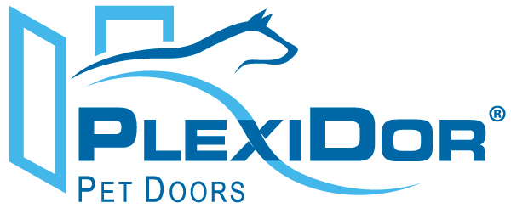

For Immediate Release
Maya Sullivan, PlexiDor Pet Doors
maya.sullivan@plexidors.net
941-752-7021 ext. 205

Triton Animal Supplies partners with PlexiDor® Performance Pet Doors

Bradenton, Fla. (March 15, 2013) – Triton Animal Supplies of Edmonton, Alberta, Canada and PlexiDor Pet Doors, Bradenton, Florida have partnered in Western Canada.
Triton Animal Supplies was started in 2006 by Hardy and Nicole Scheming with the goal of providing pet stores located in Western Canada with quality pet care products. They service approximately 300 pet retail accounts in the region and employ six outside sales representatives.
PlexiDor Performance Pet Doors has manufactured pet doors at its facility in Bradenton, Florida since 1985. PlexiDor pet doors do not require replacement flaps, provide maximum energy efficiency and added security with lock, key and steel plate.
“We are excited to partner with Hardy and Nicole Scheming of Triton Animal Supplies”, says Robert Wollet, Sales Manager of PlexiDor. “Triton’s coverage of Western Canada will enable pet parents in that market to purchase a PlexiDor pet door through their large following of pet retailers. Our new PlexiDor point-of-purchase display will be placed in pet retailers all over Western Canada that will offer shoppers to see first hand the quality of a PlexiDor Performance Pet Door”.
PlexiDor Performance Pet Doors are available through a nationwide network of authorized dealers with prices ranging from $149 to $1249. Visit www.plexidors.com for more information and to find a dealer near you.

About PlexiDor
Since 1985, PlexiDor Performance Pet Doors has manufactured pet doors at its facility in Bradenton, Fla. PlexiDor Performance Pet Doors are professionally engineered and manufactured from high-quality materials made in the United States in an effort to provide years of safe, trouble-free service for consumers and their pets. PlexiDor Pet Doors do not require costly vinyl replacement flaps and its frames are made from heavy-duty anodized aluminum that will not rust, bend, crack or warp. Engineered with energy efficient panels, PlexiDor Pet Doors will result in reduced energy costs, ideal for extreme climates. PlexiDor also offers a 5-year limited residential warranty and a
90-day money back guarantee.

###

