Editorial Contact:
Maya Sullivan
(941) 752-7021 ext. 205
maya.sullivan@plexidors.com

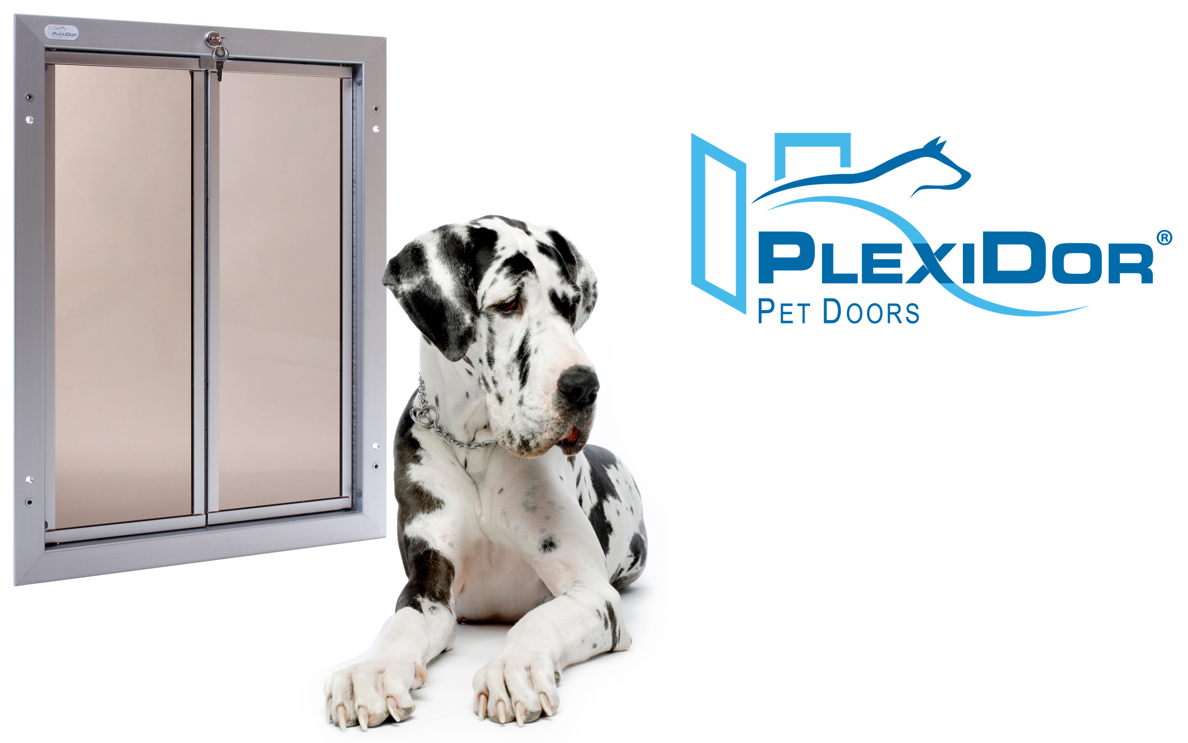
NEWS RELEASE
For Immediate Release

Extra Large Dog … Extra Large Dog Door

Bradenton, Fla. (July 23, 2013) - - Extra-large dog breeds like the Great Dane, St. Bernard, Old English Sheep Dog, Newfoundland, Irish Wolfhound, Rottweiler, and Great Pyrenees typically gain exit to the backyard through a human sized door. Since many of these dogs can exceed 200 pounds and have a shoulder height of three feet or more, owners have had no other choice other than to play doorman to these extra-large breeds … until now!

PlexiDor Performance Pet Doors, a manufacturer of high quality pet doors for 28 years, has designed an extra-large dog door that even the largest dogs can access without damaging the door while doing so.

PlexiDor pet door frames are engineered using hardened aluminum that prevents bending. The frames will never rust, crack, or warp. The unique saloon-style panels are made of hardened, shatter-resistant acrylic and are sealed with industrial-grade weather stripping that results in maximum energy efficiency. The panels come equipped with factory installed aluminum trim that is designed to prevent the panels from being damaged by chewing breeds and to provide added strength to the entire door. The combination of these rugged and durable materials results in a dog door that can take the pounding of large breeds that may sometimes hit the door at a full run.

“The PlexiDor extra-large dog door was one of the most challenging sizes we have ever tackled,” says Robert Wollet, Sales Manager for PlexiDor. “First, we had to gain an understanding of the sheer power these extra-large dogs can generate. We had our work cut out for us, yet we met the challenge.”

PlexiDor PD XL weighs approximately 18 pounds out of the box and can be mounted into a standard household door or through a wall up to 12 inches thick. PD DOOR and PD WALL are available in three colors: silver, white, and bronze. Each door comes equipped with a lock, key, and steel security plate to help prevent intruders from entering a home.

PlexiDor Performance Pet Doors are available through a nationwide network of authorized dealers, with door prices ranging from $149 to $1,249. Visit www.plexidors.com for more information and to locate a dealer near you.

About PlexiDor

PlexiDor Performance Pet Doors has manufactured high quality pet doors since 1985 at its facility in Bradenton, FL. PlexiDor Performance Pet Doors are professionally engineered and manufactured from high-quality materials made in the United States and provide years of safe, trouble-free service for consumers and their pets. PlexiDor Pet Doors do not require costly vinyl replacement flaps, and their frames are made of heavy-duty anodized aluminum that will not rust, bend, crack, or warp. Engineered with energy efficient panels, PlexiDor Pet Doors reduce energy costs and are ideal for extreme climates. PlexiDor also offers a 5-year limited residential warranty and a 90 day money back guarantee.

- High-resolution images are available at www.plexidors.com or upon request by contacting Maya Sullivan at maya.sullivan@plexidors.com.

###

